**Each question below is worth 10 points. Please answer clearly in the space provided.**

1. What is API? What is API used for?

API stands for Application Programmers Interface. It is a written set of programming instructions that allow the program to access another software application of a Web based service or tool or to make the process easier for other programmers.

1. A sound file decompressed in its entirety is in the lossless format while one that is partially decompressed is in the lossy format. Unlike these two the raw format is not decompressed at all.
2. What is a Java constructor?

A Java constructor is special code that will be executed automatically whenever a new instance of an object in a class is created.

1. Describe the difference between world constructors and actor constructors.

Constructors of the world class can be used to initialize world objects. Likewise, the constructors of the actor class may be used to initialize actor objects. The actor constructor initializes the object, and the world constructor is for the animation.

1. Which would not be found in an API document:
   1. Data types
   2. Software operations
   3. Resulting outputs
   4. Necessary inputs
   5. All of the above
   6. None of the above
2. What Java method is used to play sound in Greenfoot? Provide the return type and any parameters it needs.

playSound. This method uses a sound file name as its parameter and has a void return type. Syntax is Greenfoot.playSound(“slurp.wav”);

1. Explain the meaning of the term programmatically.

This means directly from the code.

1. The screen print below represents a fragment of Greenfoot Documentation. Explain how to access this information in Greenfoot.

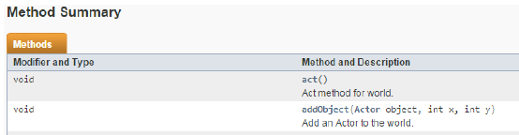

To access Greenfoot API, you go to the project, and under the help tab you should see a tab for Greenfoot documentation.

1. The code sample: Greenfoot.playSound(“crunch.mp3”);
2. Extracts the compressed sound file crunch.mp3
3. Plays the sound clip during a Greenfoot animation
4. Throws a java.lang.IllegalArgumentException
5. All of the above
6. None of the above
7. Explain the role constructors play in the construction of new Java objects.

Constructors play in the construction of new Java objects to initialize the new object.